Each of the five Groups have for UF Students who will be assigned a specific administrative role for each group:

Zoom Meeting organizer- Sends an email as soon as groups are announced to all members in group to find out which times they are NOT available during a specified four-day window. After receiving the feedback, determine the best time and date of the 90-minute brainstorming session and send a Zoom meeting invitation to each member of the group. At the beginning of the meeting, you will be responsible for greeting members and recording the meeting before turning the meeting over to the Part 1 Facilitator. During Part 1 and Part 2 you will be the timekeeper to ensure that each facilitator does not go over 45 minutes. Immediately after the meeting, send the recording link to each group member.

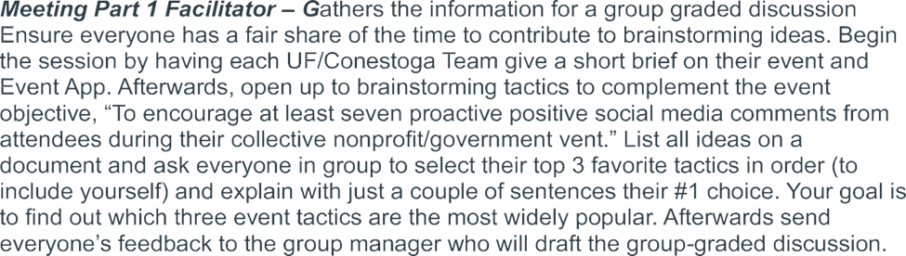

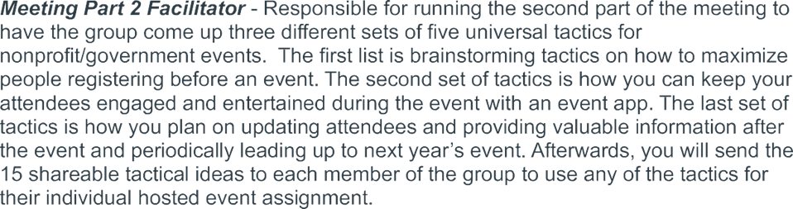

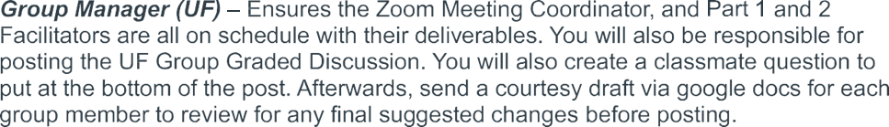

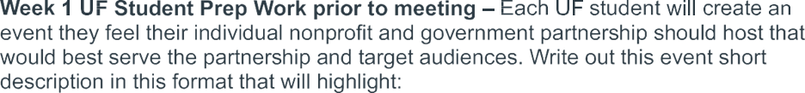
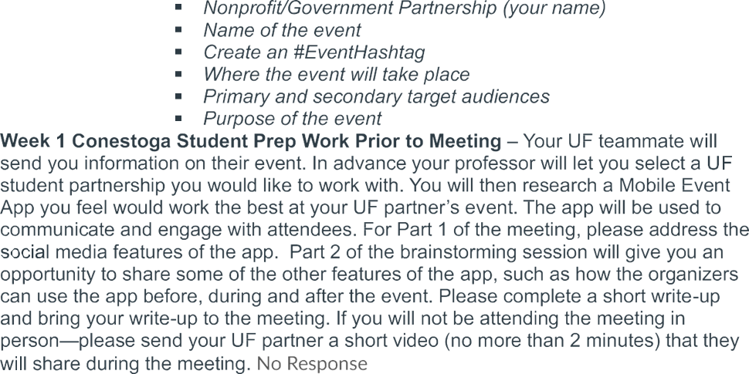

- Encouraging attendees to generate social media during the event.
- Before the event– encouraging people to attend
- During the event– Keeping attendees internally informed and engaged
- After the event– being a continuous, connective source of information and support.
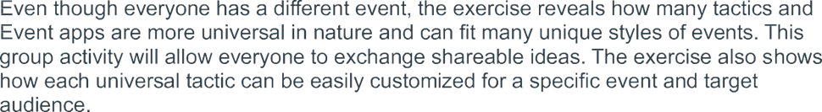

Collaboration Activity
