Inaugural Virtual Exchange AY 2023- 2024
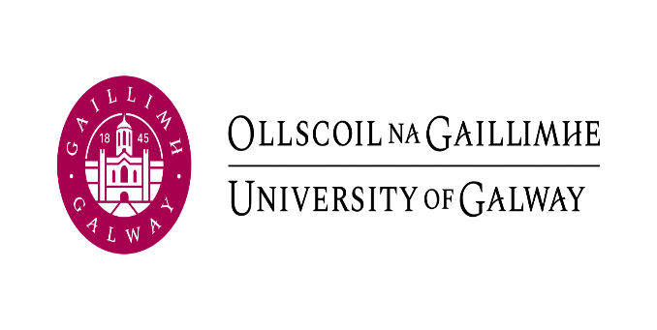 | 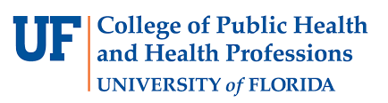

University | University of Galway Ireland | University of Florida  USA
Lecturer | Dr Mary-Pat O Malley Keighran Ph.D. | Dr. Sharon M. DiFino, Ph.D, CCC-SLP
 | Programme Director BSc Speech & Language Therapy,  Programme Co-Director MSc Childhood SLCN  Disicpline of SLT, School of Health Sciences | Clinical Assistant Professor Director of Bilingual Language Access and Outcomes Lab  Speech, Language, and Hearing Sciences  College of Public Health and Health Professions
Programme & Year | Year 1 BSc Speech & Language Therapy | Year 4 BS Health Sciences, concentration Speech, Language, and Hearing Sciences
Modules | SL124 1 Professional Studies 1 | SPA 4250 Speech Sound Disorders
Learning Outcomes | Learning Outcome 2:  Begin to develop their personal strengths and areas for professional development e.g., team roles; self-awareness and self-care; academic writing; library skills; academic integrity (e.g., citation, referencing, and plagiarism).  Learning Outcome 8:  Outline key components of collaborative working practices with families and professionals in health, social and education contexts.  Learning Outcome 10:  Describe the key components of cultural competence. | Learning Outcome 14:  Discuss the ways in which cultural factors affect the clinical management of individuals with speech disorders.  Learning Outcome 15:  Describe ethical issues that relate to the clinical management of speech disorders.
CORU SOPS covered | 1.3, 1.5, 1.8, 2.2, 2.5, 3.4, 4.1, 5..1, 5.6, | Program and Clinical Certification Standards:  IV- B Knowledge of basic human communication processes, including their biological, neurological, acoustic, psychological, developmental, and linguistic and cultural bases.
Number of hours | 100+ minutes (50 minutes x 2 sessions) | 180-200 minutes (90-100 minutes x 2 sessions)
Number of students | ~32 | ~47

Additional Student Learning Outcomes
Knowledge | Increase in cultural views, dimensions of national culture, increase in self-awareness.
Attitudes | Cultural empathy, curiosity, humility, compassion
Skills | Cultural competency,  effective communication with diverse populations  problem solving in a team.

Proposal for Virtual Exchange with University of Galway, Ireland
International Perspectives on Culturally Responsive Care as Evidence-based Care
Fall 2023 Semester November 16th and November 30th (VE partners asynchronously met with students on November 16th in preparation for November 30th synchronous session).

Goal / Objectives:

Students who engage in the Virtual Exchange will be able to:

- Discuss international perspectives on Culturally Responsive Care.

- Identify strategies advocating for Culturally Responsive Care for heritage speakers seeking care.

Technology Tools:
- For communication and collaboration: Zoom, WhatsApp
- Dateful Time zone converter: https://dateful.com/time-zone-converter (if we are synchronous, then this tool is helpful with the time difference NOTE: USA changes time on November 5th, 2023)
- Canvas Discussion post forum/ Canvas (free version)
- Teams (Notepad), Padlet, Flipgrid
- Google documents

Materials:
Readings:
Excerpts from American Speech Language and Hearing Association journal AHSA Leader that address clinical service delivery, cultural, and professional development, and changes in the field.

Bilingualism and children with intellectual disability:
https://theconversation.com/why-being-bilingual-can-open-doors-for-children-with-developmental-disabilities-not-close-them-196599 - :~:text=We found Welsh-English bilingual,skills in their additional language

Bilingualism & children with Down Syndrome: a parent’s perspective (11.09) https://www.youtube.com/watch?v=OsF6WUcGFwg

Why being bilingual is good for your brain BBC 4
https://www.bbc.co.uk/ideas/videos/why-being-bilingual-is-good-for-your-brain/p0gl245p (5.23)

Culturally Responsive Guidelines for Serving Families of Bilingual Children Who Stutter:
https://pubs.asha.org/doi/epdf/10.1044/2022_PERSP-21-00235

Self-reflection tools from ASHA:
- Self-reflection tool for cultural competence: https://www.asha.org/siteassets/uploadedfiles/multicultural/self-reflection-checklist.pdf
- culturally-responsive-practice-checklist.pdf

Hofstede’s Six dimensions of National Culture Theory & Country Comparison Tool
- https://geerthofstede.com/culture-geert-hofstede-gert-jan-hofstede/6d-model-of-national-culture/
- https://www.hofstede-insights.com/country-comparison-tool
- That’s Unheard Of https://www.thatsunheardof.org/
Assessment:
UF student V.E. activities completed November 2023 will be worth maximum of 6% of overall final grade in the course.

Process:

  - November 23rd Session 1: Introduction to Culturally Responsive Care (U Galway)

- UF students do the same as Galway students as outlined below:
- Galway:
  - Self-directed session where students must watch the 6 Hofstede videos on the dimensions and complete the Illustrative Quotations Padlet. MP will give example of an expected post. Instructors will provide the link to the 6 dimensions of culture and have them watch the short 10-minute videos in preparation. Students use the comparison tool to analyse the similarities and differences between Ireland and the U.S. and report in the Padlet
  - Questionnaire: Complete the self-reflection tool for cultural competence: https://www.asha.org/siteassets/uploadedfiles/multicultural/self-reflection-checklist.pdf
  - Students will reflect on how Culturally Responsive Care might impact how a professional in the field would address the etiologies, characteristics, and cultural correlates of speech disorders for their population.
  - Culturally Responsive Service Delivery Checklist: http://www.arsha.org/documents/ArSHA_CLD_Culturally_Responsive_Service_Delivery_Check_List_2021.pdf

  - Think of favourite place that they have visited or would like to visit in preparation for Ice Breaker activity.

November 30th Session 2 via Zoom
- Opening 5 minutes in main room: welcome and introductions and or hopes for the virtual exchange

- Go to break out rooms for “Where in the World” Ice Breaker Instructions: (Instructions provided in PPT)

- Synchronous. 15-20 minutes to complete.

- Everyone thinks of three clues that describe, but don’t give away, their favorite place that they have visited or dream of visiting one day.

- When ready, each person gives their name and their three clues, and the rest guesses where in the world they are describing. Give each person a minute or two to explain what they like best about their favorite place in the world.

3. Transitional activity: Finding common ground: Viewing of the Derry Girls clip. (3.59)
https://www.youtube.com/watch?v=0j0OF-TlyAY
After watching the clip introduce the idea of diversity as a dynamic, relational reality that exists between people (Barrera & Kramer, 2017). No single person can be said to be diverse, culturally or otherwise, except in reference to other people or contexts (Barrera & Kramer, 2017). Diversity, unlike other characteristics e.g. hair colour, cannot exist independently of its context. ‘Diversity is thus, never about who they are; it is about who we are ’ (Barrera & Kramer, 2017:8).

Students placed in small groups. Discussion about similarities and differences between Irish and US students -15 minutes and then 10 to get feedback from each group.

Brief recap of what has been discussed and learned so far in the Virtual Exchange including thoughts on the limits of the self-reflection questionnaires (we can all think, we are culturally responsive or informed but are we in our everyday our clinical practice?)

In small groups, students discuss how Culturally Responsive Care might impact how a professional in the field would address the etiologies, characteristics, and cultural correlates of speech disorders for their population. Feedback to us and the full class.

QUESTIONNAIRE FOR FEEDBACK
University of Galway completed a quiz for feedback
University of Florida completed a Discussion post in their Canvas course shell and completed a pre- and post-survey with the UFIC Global learning

